

2 Minute Form
Trip Name: Raglan Harbour – Waingaro Landing
Check-in Name and Phone:
Date: Branch:
Leaders
Cell Phone Number
VHF Call Sign &/or Vessel Name
Vehicle make, model, registration, colour
General Plan
Note: If plan changes, you must notify your Check-in person.
Latest Time Off the Water |  |  |  |  | TMP used²⁰
Tide/ Forecast Lake Level | Low |  |  | High | Other
Communications Carried²¹
Communications | We will be communicating as a group on VHF Channel _____
Equipment Carried
Trip Report
(Use other side if more space required)

Activity | Sea kayaking – Raglan to Waingaro Landing | Centre | North Shore | Location |  |  | Raglan Harbour |  | Difficulty¹ |  |  | Intermediate
Activity Description | With inward tide paddle from motor camp to Motukokako Pt, then along NW side of Paritata Peninsula to Waingaro Landing and if sufficient tide up towards the Kerikeri River. One way or Return on outward tide. |  |  |  | Leader qualification req.² |  | Sea kayak
Get in Location | Raglan Holiday Park, Wainamu Beach |  |  |  | Chart/ Map no.⁴ |  | 260-R14 |  | Distance |  |  | 12km one way  24km return
Get out Location | Waingaro Landing |  |  |  | Coastguard Channel |  | 86 & 16 |  | Nowcasting |  |  | 22
Emergency get out ⁵ | Farmland around harbour |  |  |  | Emergency / Coastguard Station |  | Raglan |  | Phone |  |  | *500  09 303 4303
Emergency get out ⁵ |  |  |  |  | Drinking Water⁶ | no |  | Toilets⁷ |  |  | At camp only.
Emergency Response | Refer Emergency Response Booklet |  |  |  |  |  |  | Parking⁸ |  |  | At Landing or Motor camp. Shuttle req’d if one way trip. Room for only 6 cars at Landing.
Specific Equipment Required⁹ | Tide chart. Topo map and compass |  |  |  | Working Communications equipment in this area¹⁰ | Cell phone  Sat phone |  |  |  | Mountain Radio |  |  | PLB  VHF
Other resources  and notes¹¹ | As many creeks and inlets, advise plotting course on map and taking a bearing. Once up Waingaro Landing inlet – to find Landing look out for limestone rocks on L, and paddle to R to gap in mangroves. |  |  |  | Weather Parameters¹² | 15 knot-20 knots
Previous incidents¹³

Safety Management¹⁴
Hazard |  | Significant?  - E/I/M |  | Management Strategy¹⁵ |  |  |  | Hazard | Significant?  - E/I/M | Management Strategy¹⁵
Cold Water |  | Yes - M |  | Carry spare dry clothes and shelter |  |  |  | Deep Water | Yes - E | Correctly fit PFDs
Medical Conditions |  | Yes - M |  | - Leader has first aid qualification  - Ask customers about medical conditions |  |  |  | Bad Weather | Yes - M | Understand weather forecasts.  Have back up plans or pull out if necessary
Capsizing |  | Yes - M |  | - Correctly fit PFDs  - Skills at performing rescues. |  |  |  | Heat / Sun | Yes - M | - Protective Clothing (worn), Sunglasses, Hat  - Sun Screen  - Plenty of drinks
Panic |  | Yes - M |  | Ensure conditions match level  of skills |  |  |  | Obstacles | Yes - M | Awareness of reefs, navigational hazards, nets
Other Hazards |  | Yes - M |  | Harbour very tidal. Tidal current strong – beware of getting too close to wharf & moored boats, and getting swept past Motor Camp if doing return trip. |  |  |  | Other Vessels | Yes - M | - Understand the “rules of the sea”  - “Be seen” – Have two of the following; flag, brightly coloured kayak, brightly coloured Pfd or hat. At night: an all- round white light & a powerful torch.
Other Hazards |  |  |  | Duck shooters. Avoid first w/e in May. |  |  |  | Other Hazards |  | Fishermen – look out for lines off wharf and points.
Written up by: | Ruth E. Henderson |  | Approved By: |  | Rob Howarth | Signed: |  |  | Date: | 26/5/2014 | Review in: | 12 months from date of approval

Additional Information Sheet (Optional)
Introduction (A general introduction)
Description (A description of the tour – as if you were selling the idea to someone)
Local Attractions |  | Transport/ Local Operators
Wainui Reserve | Contact details |  | Contact details
Bridal Veil falls
Waingaro Hot Pools
Local Eateries
Cambodian Licensed Restaurant – fantastic food and cheap prices | Contact details  Bow St. Raglan  07825 0952
Accommodation/ Campsite Locations |  |  | Facilities
Name | Raglan Kopua Holiday Park |  | Cabins | y | Fuel | At Town nearby
Phone | 07 825 8283 |  | Showers | y | Power | y
E-mail |  |  | Toilets | y | Water Access | y
Website | www.raglanholidaypark.co.nz |  | Laundry | y | Pool | n
Physical Address | Off Marine Pde |  | Water | y | Fires Allowed | n
Other | Use the backpacker’s part of the camp. Has two small ensuite bunkrooms with small kitchen and lounge in between and several std spacious bunkrooms, plus huge kitchen and dining room. |  | Supplies | At Town nearby
Other information

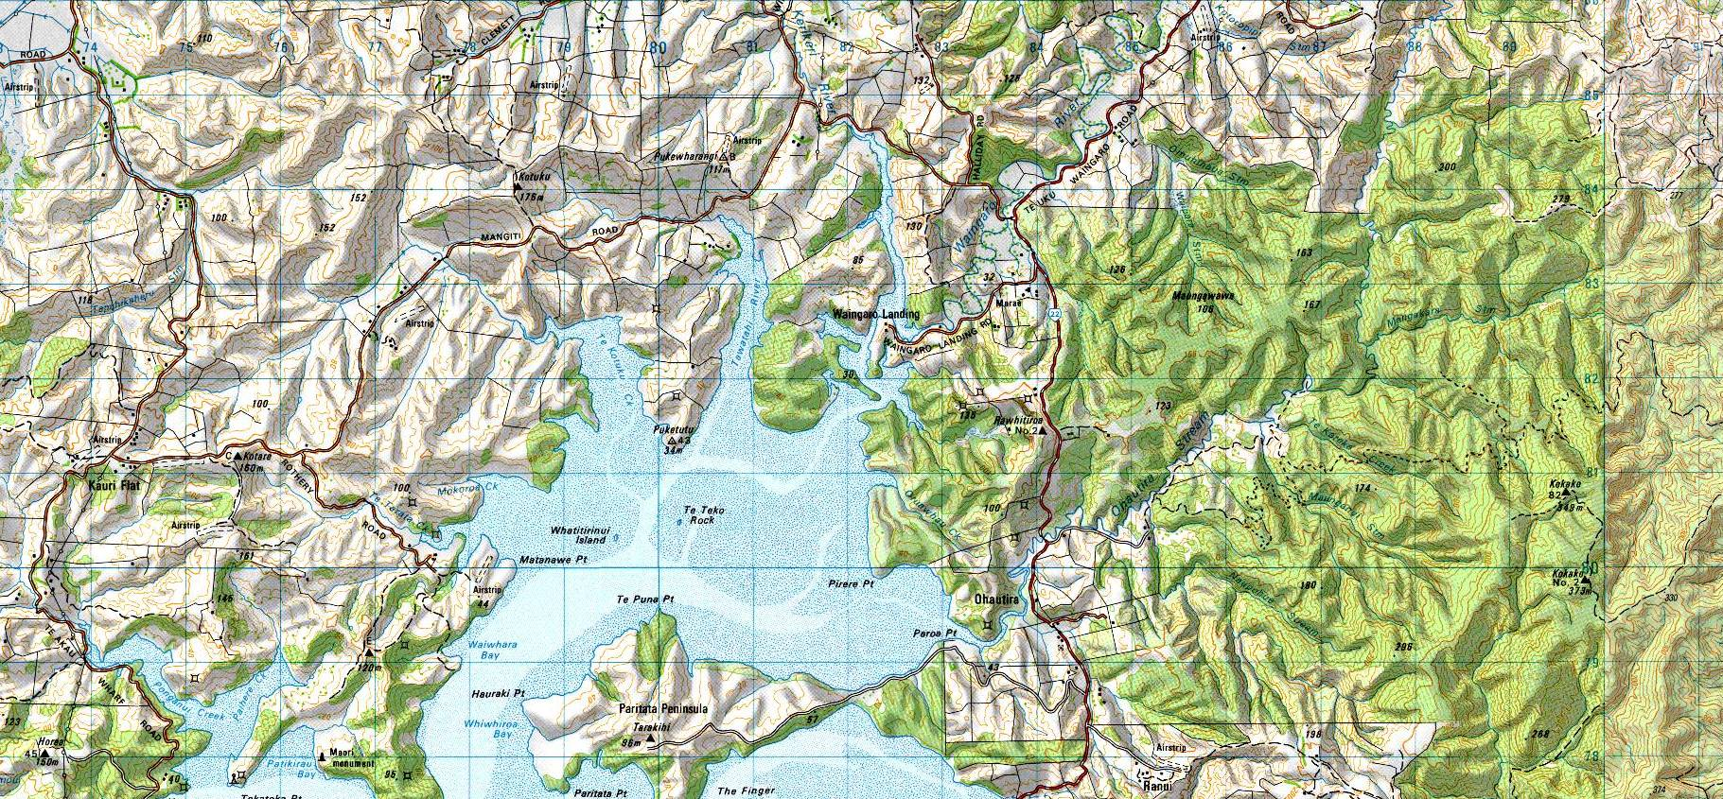

Activity Equipment Check list
Equipment List
- Helmet (rivers & surf) Group Gear
❑ Beanie / hat  Split paddles
❑ Thermals  Repair kit
❑ Paddle Jacket  Fire lighting
❑ PFD  Cooker/thermos
❑ Spray deck  Spare thermals
❑ Booties  Tow system
❑ Water & food  1st Aid Kit
❑ Kayak & paddle  Flares
Group - Oceans & Lakes  Compass
❑ Pumps & Paddle Floats  Charts / Maps
Group - River  GPS (optional)
❑ Throw ropes  Knife (cut rope)
❑ Pin kit & saw  Emergency Shelter

In case of emergency: Dial 111, Mayday: VHF Channel 16

Kayaking Check list

❑ Trip plan
❑ Latest weather forecast
❑ Conditions match skills?
❑ Hyperthermia (hot) &
Hypothermia (cold)
❑ On & off water safety
❑ Environmental concerns
❑ Emergency Procedures include emergency get out.
❑ Working communication devices
e.g. VHF radio, mobile phones, PLB
❑ Specific safety issues for this trip
❑ Participant list
❑ Any medical conditions
❑ All participants keen to proceed?

❑ Trip Plan/ 2-minute form lodged with Ops. Manager

Appropriate wind conditions to run trips:
Novice - no significant surf or swell, wind under 15knots
Intermediate- surf or ocean swells less than 1.5 meter or wind under 25 knots.
Advanced- any condition that is suitable to the trips aims

At conclusion of trip:
Contact check in person
Group Debrief.

Check in Person Ph:
__________________ Mobile
__________________ Work
__________________ Home

Activity Document Cover Sheet

Activity:
Date of Activity:

Activity reports. Is all relevant information present:
– Approved Trip Management Plan (TMP)/ 2 minute form
– Club Trip Participant Sheet
– Weather forecast
– Activity Check List
– Trip report (May be on the 2 minute form)
– Accident / incident reports
Leaders Signature:
Date:

